SUPPLEMENTAL KRONOS TRAINING FOR EMPLOYEES

Login to Kronos

Click on the menu bar

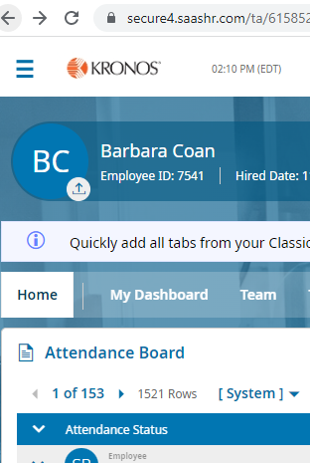

Click on the single person icon, then Help

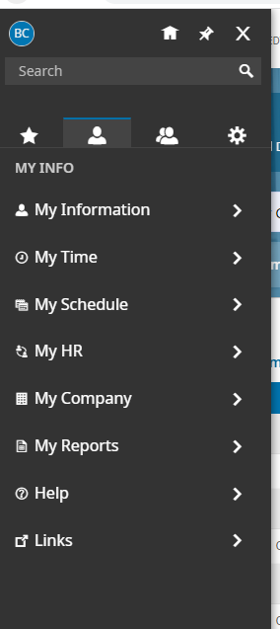

Click on Learning Center

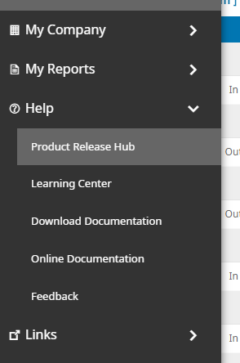

Type “employee learning plan” into the search bar

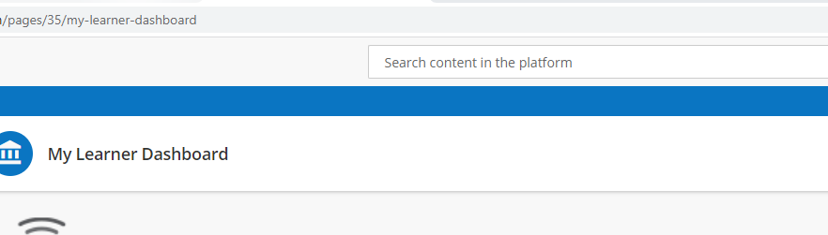

Click on Employee Learning Plan

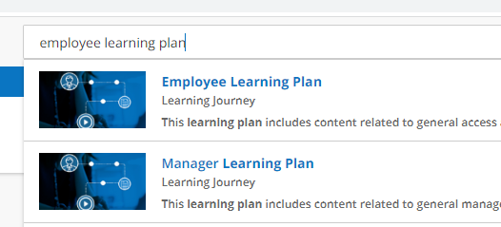
There are seven short, self-paced, learning modules for you to choose from

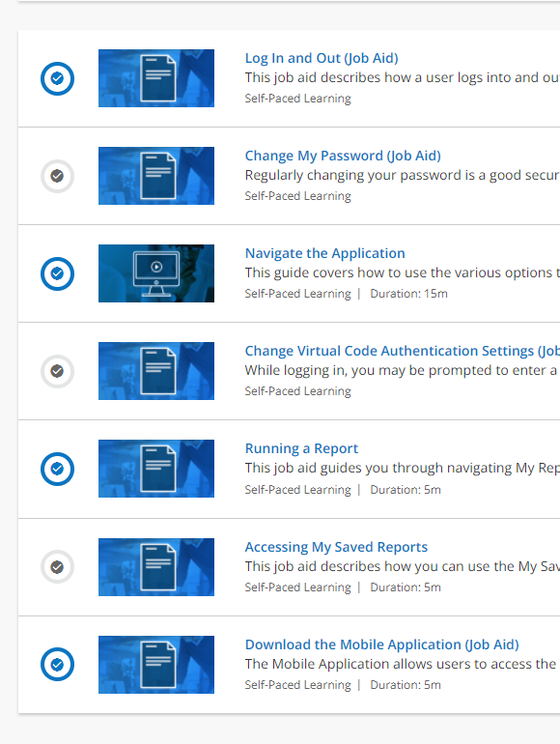

Other suggested learning modules (type the topic into the search bar):

Timesheets:
Submitting timesheet change requests
How to manage exceptions (late arrival/early dismissal)
How to print a timesheet

Time off requests:
Requesting time off
Cancelling time off requests

*This topic has both self-paced and instructor-led modules

